**Lab 7 Report**

**LAB 7: Mobile UX Design**

**Name: Hamza Mehmood**

**Class & Section: BS-SE 6TH (Evening)**

**Roll number: SP-21-110**

**Assigned Design: E-Commerce Design**

**Task 3 Assessment:** Students will create an interactive prototype of the mobile interface using prototyping tools or techniques. They will then conduct usability testing by inviting participants to interact with the prototype on actual mobile devices. Students will observe and gather feedback on the usability, efficiency, and overall user experience of the mobile interface.

Do attach screenshots with respective Link

**Version 1:** <https://www.figma.com/file/oLlFLGaObcpWjz8cZOSavC/Ecommerce-store-app-(Community)?type=design&node-d=1%3A3&mode=design&t=Cp84jwZBocx6fYMv-1>

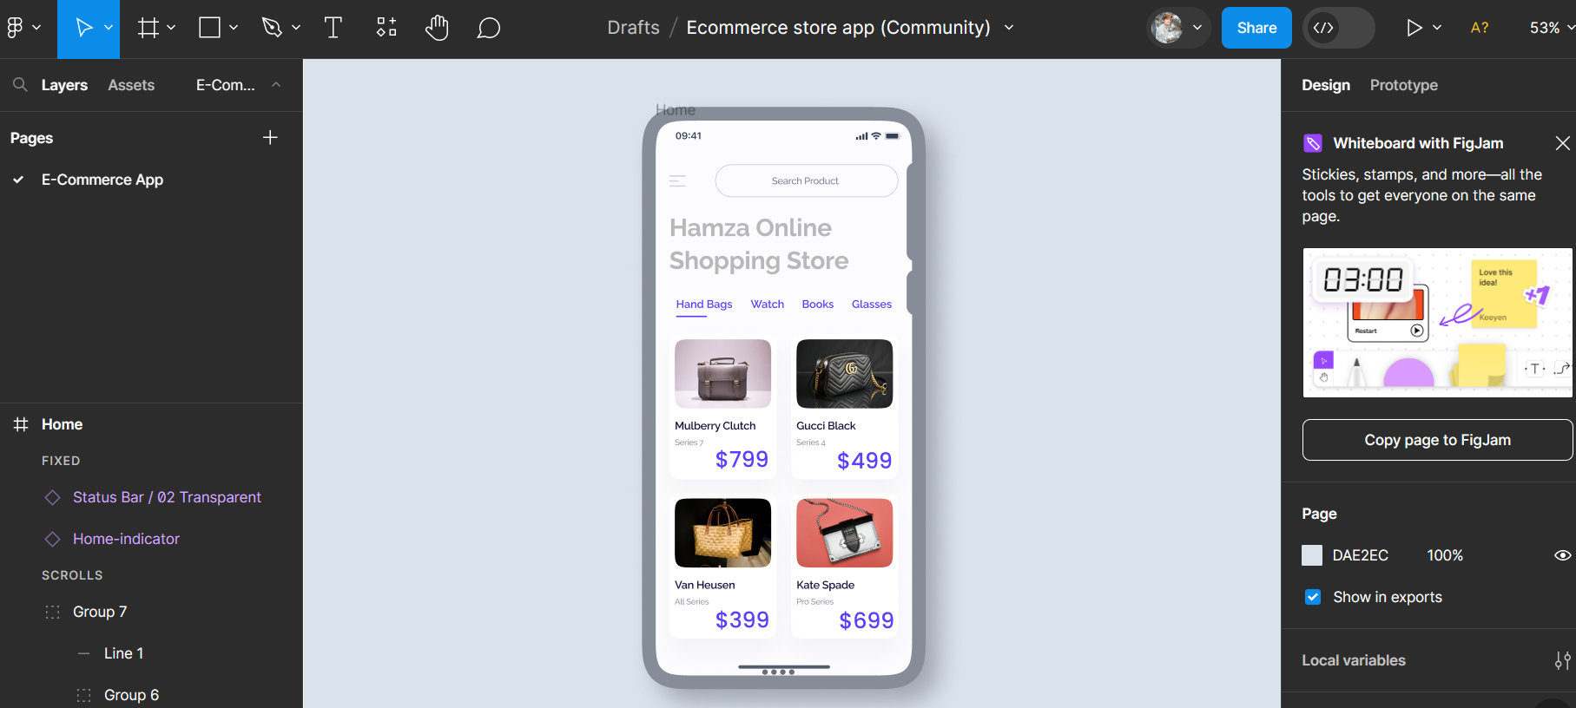

**Evaluating Recommendations:**

* The menu breadcrumb is too light to be visible.
* No Search Icon in search bar.
* Main Heading is too light to Visible.
* Sub Menus are of same color.
* Price font is too big.

**Task 4 Assessment:** Based on The feedback and insights gained from usability testing, students will iterate and refine the mobile interface. They will prioritize usability issues and design improvements identified during the testing phase. Students will make necessary revisions to the interface design, considering user feedback, and incorporating best practices for mobile UX design.

Do attach screenshots with respective Link

**Version 2:** <https://www.figma.com/file/oLlFLGaObcpWjz8cZOSavC/Ecommerce-store-app-(Community)?type=design&node-d=1%3A3&mode=design&t=Cp84jwZBocx6fYMv-1>

